**EC2 TO SERVER CONNCECTION**

* Go to ec2 and click security group click create security group.

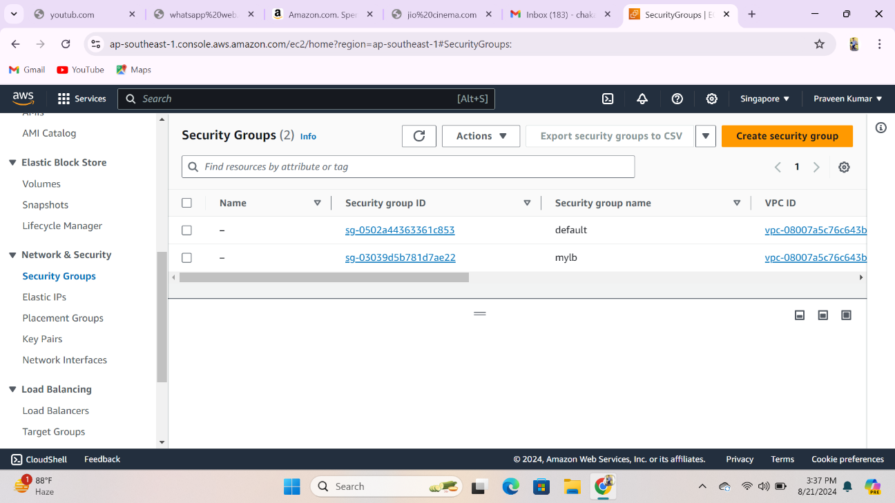

* Name = mylb
* Vpc =defult
* Inbound rules and add rule and ssh &http
* Now create a 3 instances in aws account
* Ec2 go to instances lunch instances name = praveen ,papa & lucky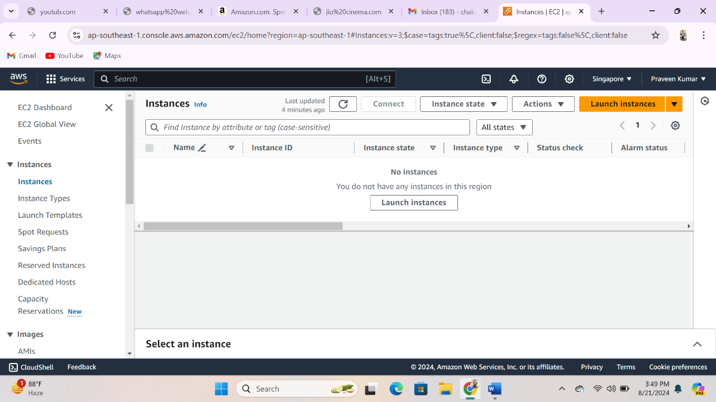

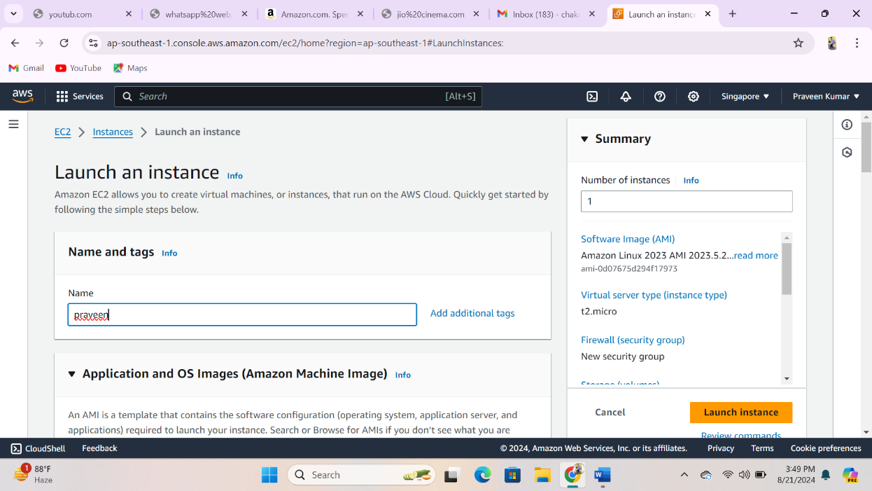

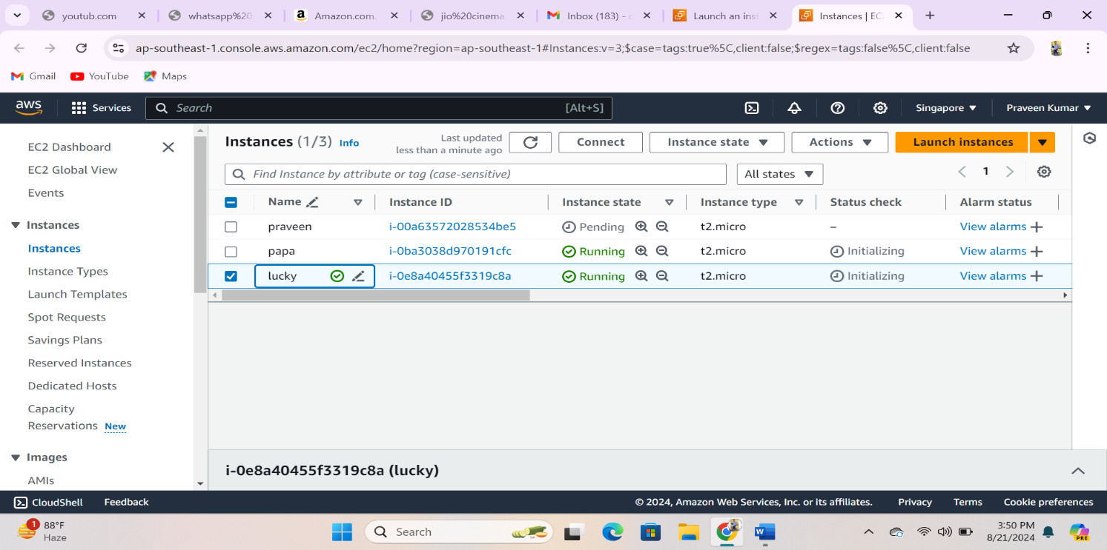

* Now cennect praveen instance and set hostname= praveen and install ingnx 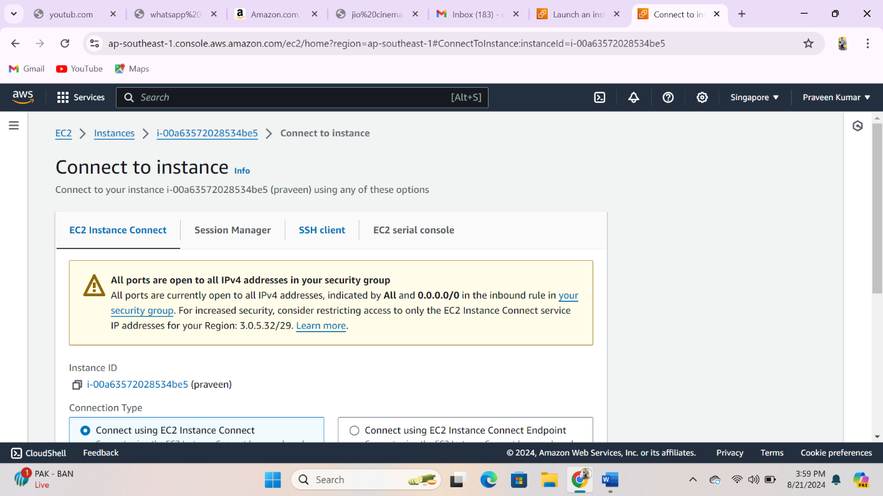
* Chosse the ssh client

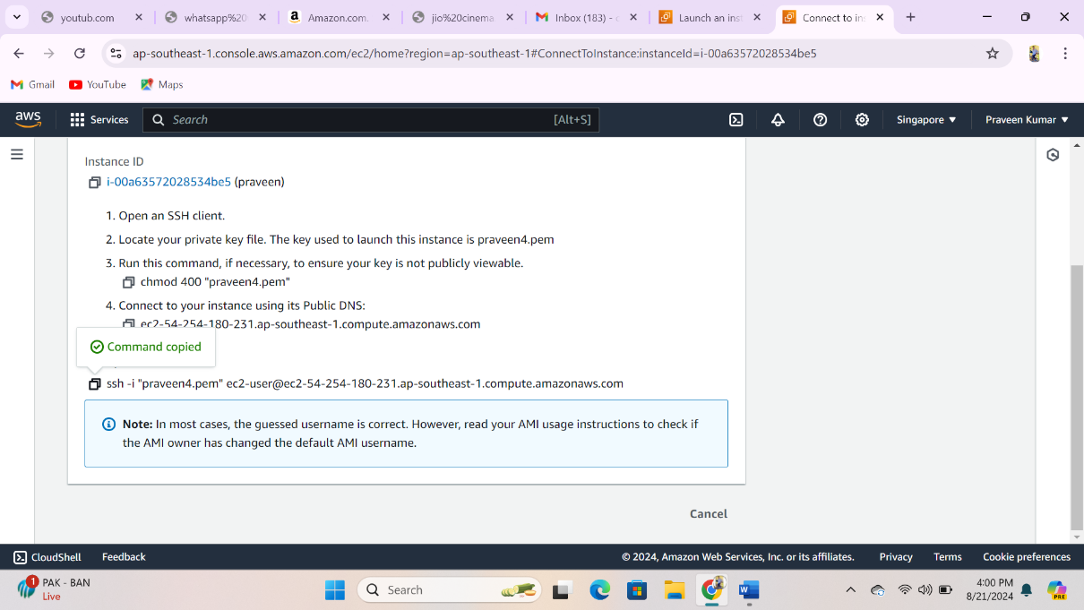

* Copy the url
* Now we to go on git bash to install ingnx & connect to server

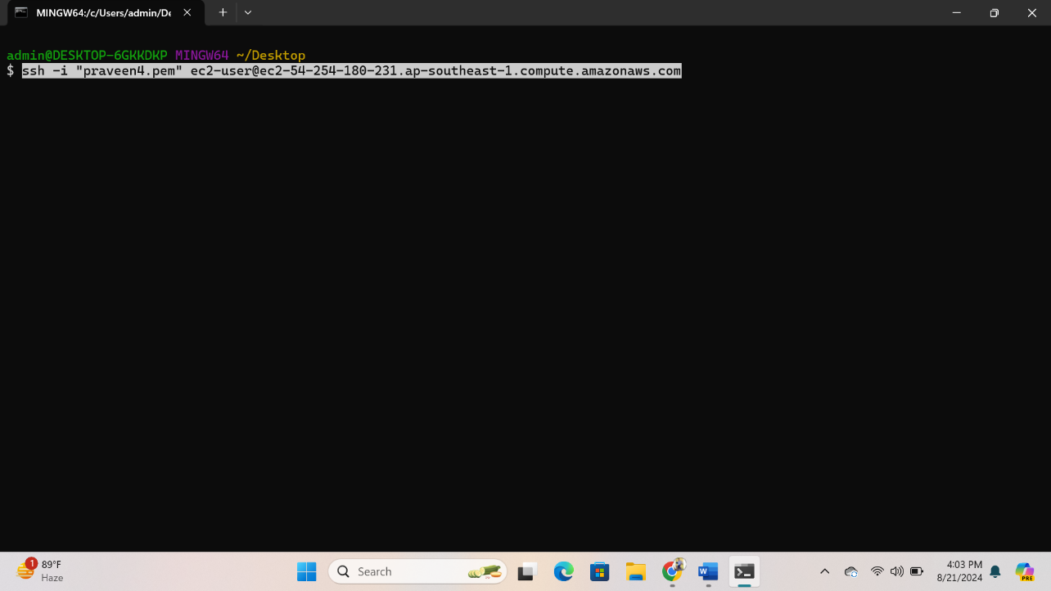

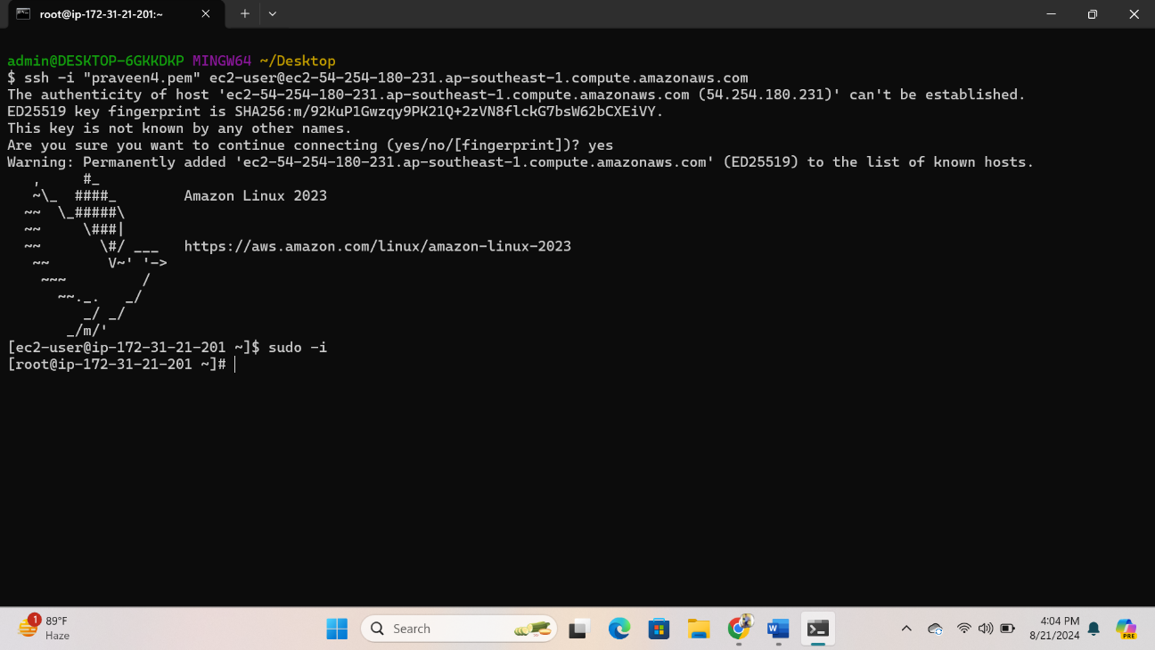

* We have check here because of connect of root acccou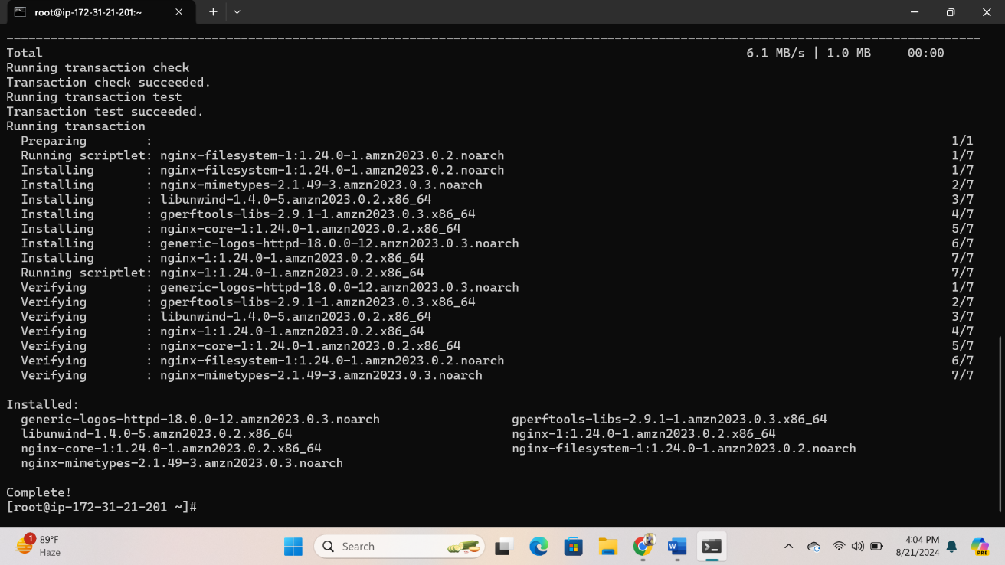
* Installed by nginx

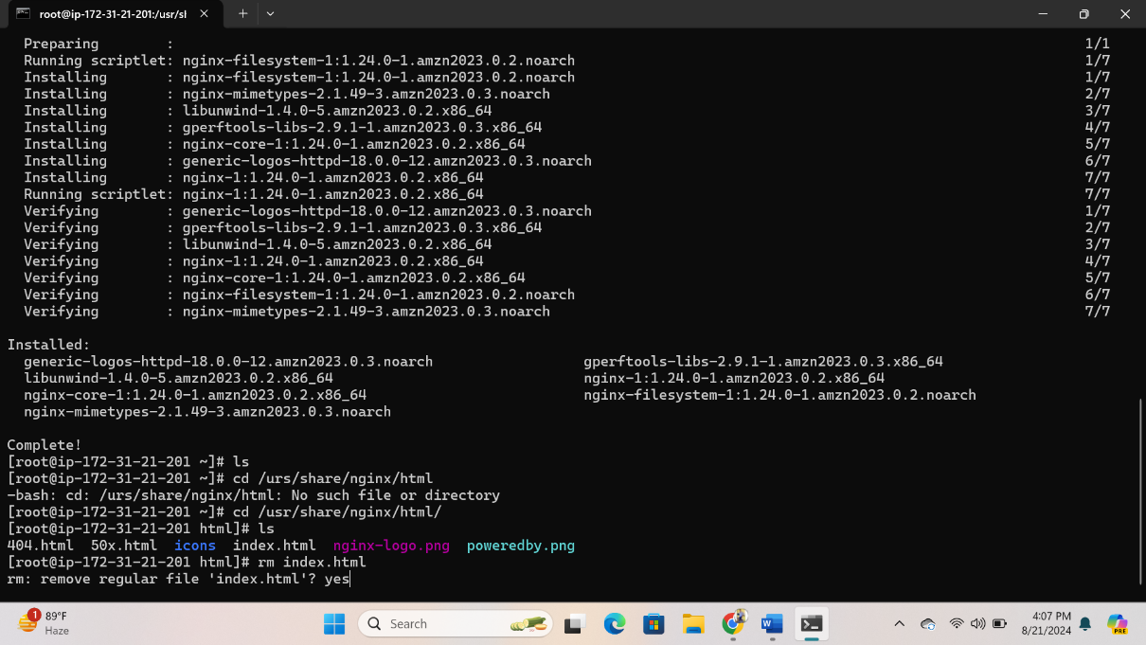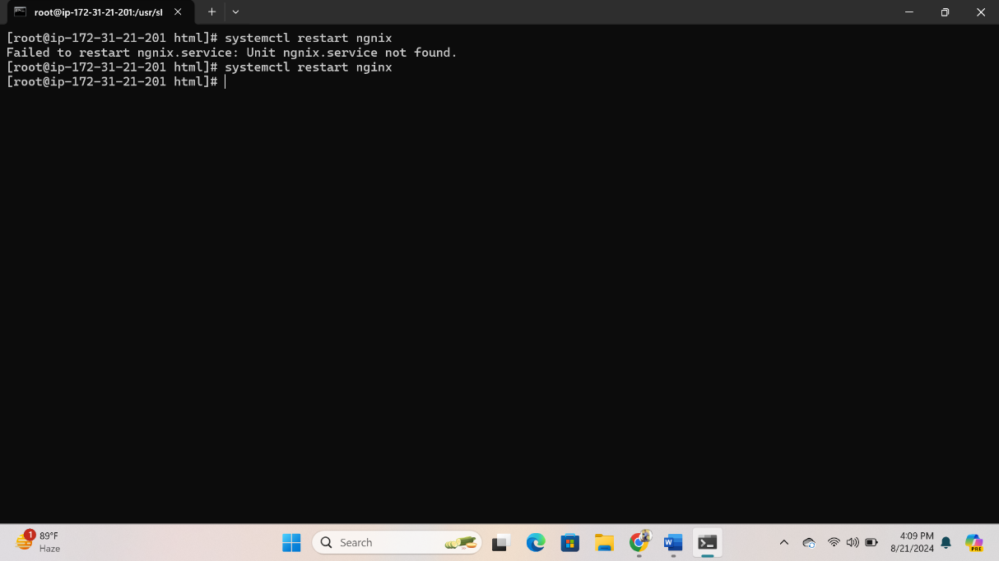

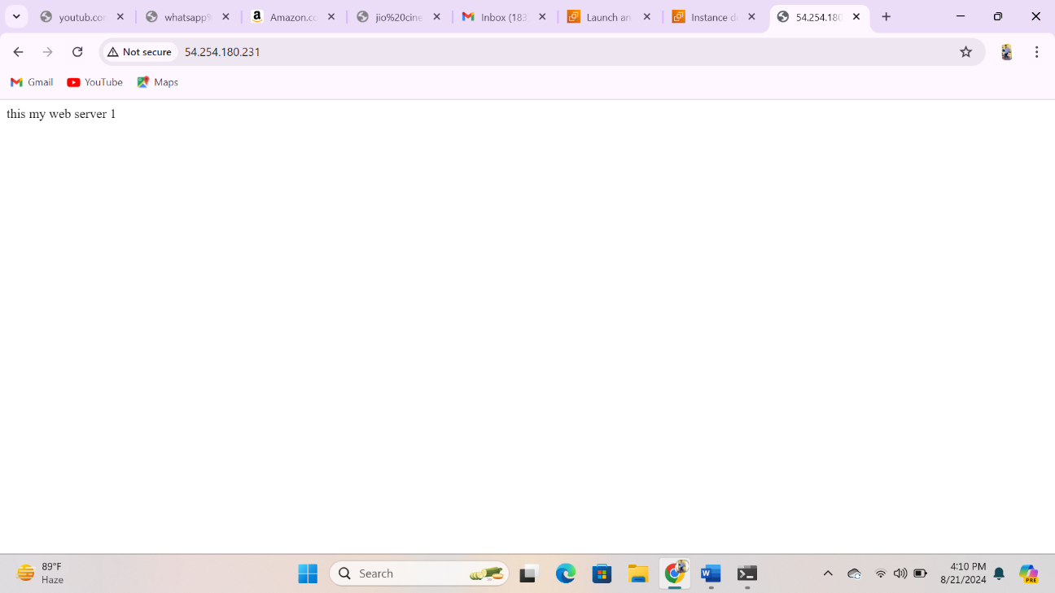

* After installed by nginx to conncted to server